

Semester Two Examination, 2021

Question/Answer booklet

MATHEMATICS  
METHODS  
UNITS 1&2

**SOLUTIONS**

Section Two:  
Calculator-assumed

Student’s name

Teacher’s name

|  |  |
| --- | --- |
| Number of additional answer booklets used (if applicable): |  |

## Time allowed for this section

Reading time before commencing work: ten minutes

Working time: one hundred minutes

## Materials required/recommended for this section

***To be provided by the supervisor***

This Question/Answer booklet

Formula sheet (retained from Section One)

***To be provided by the candidate***

Standard items: pens (blue/black preferred), pencils (including coloured), sharpener,  
correction fluid/tape, eraser, ruler, highlighters

Special items: drawing instruments, templates, notes on two unfolded sheets of A4 paper, and up to three calculators, which can include scientific, graphic and Computer Algebra System (CAS) calculators, are permitted in this ATAR course examination

## Important note to candidates

No other items may be taken into the examination room. It is **your** responsibility to ensure that you do not have any unauthorised material. If you have any unauthorised material with you, hand it to the supervisor **before** reading any further.

## Structure of this paper

|  |  |  |  |  |  |
| --- | --- | --- | --- | --- | --- |
| Section | Number of questions available | Number of questions to be answered | Working time (minutes) | Marks available | Percentage of examination |
| Section One: Calculator-free | 8 | 8 | 50 | 52 | 35 |
| Section Two: Calculator-assumed | 13 | 13 | 100 | 98 | 65 |
|  | | |  | **Total** | 100 |

## Instructions to candidates

1. The rules for the conduct of examinations are detailed in the school handbook. Sitting this examination implies that you agree to abide by these rules.

2. Write your answers in this Question/Answer booklet preferably using a blue/black pen.  
Do not use erasable or gel pens.

3. You must be careful to confine your answers to the specific question asked and to follow any instructions that are specific to a particular question.

4. Show all your working clearly. Your working should be in sufficient detail to allow your answers to be checked readily and for marks to be awarded for reasoning. Incorrect answers given without supporting reasoning cannot be allocated any marks. For any question or part question worth more than two marks, valid working or justification is required to receive full marks. If you repeat any question, ensure that you cancel the answer you do not wish to have marked.

5. It is recommended that you do not use pencil, except in diagrams.

6. Supplementary pages for planning/continuing your answers to questions are provided at the end of this Question/Answer booklet. If you use these pages to continue an answer, indicate at the original answer where the answer is continued, i.e. give the page number.

7. The Formula sheet is not to be handed in with your Question/Answer booklet.

Section Two: Calculator-assumed 65% (98 Marks)

This section has**thirteen** questions. Answer **all** questions. Write your answers in the spaces provided.

Working time: 100 minutes.

Question 9 (4 marks)

The value $V$ of a block of land, in thousands of dollars, $t$ years after the start of the year $2012$, can be modelled by the equation $V=45r^{t}$, where $r$ is a positive constant.

At the start of $2019$, the land was valued at $\$86 000$.

(a) Show that the value of $r$ is $1.097$, when rounded to $3$ decimal places. (2 marks)

|  |
| --- |
| Solution |
| $$45r^{7}=86 \\ r=1.09694≈1.097 \text{to 3 dp}$$ |
| Specific behaviours |
| ✓ writes equation  ü solves to more than $3$ dp (and then rounds) |

(b) Assuming that the model remains valid into the future, determine during which year the value of the block will reach $\$400 000$. (2 marks)

|  |
| --- |
| Solution |
| $$45{\left(1.097\right)}^{t}=400$$ $$t=23.6 \text{years}$$ Hence during the year $2035$. |
| Specific behaviours |
| ✓ writes and solves equation  ü states correct year |

Question 10 (5 marks)

Sector $POQ$ subtends an angle of $108°$ in a circle with centre $O$ and radius $r$.

(a) Express $108°$ as an exact and simplified radian measure. (1 mark)

|  |
| --- |
| Solution |
| $$108°=\frac{3π}{5} \text{radians}$$ |
| Specific behaviours |
| ✓ value |

The area of sector is cm2.

(b) Determine the radius of the circle. (2 marks)

|  |
| --- |
| Solution |
| $$\frac{1}{2}r^{2}×\frac{3π}{5}=120π \\ r=20 \text{cm}$$ |
| Specific behaviours |
| ✓ indicates equation  ü calculates radius |

(c) Determine the area of the minor segment bounded by arc $PQ$ and chord $PQ$. (2 marks)

|  |
| --- |
| Solution |
| $$A=\frac{1}{2}{\left(20\right)}^{2}\left(\frac{3π}{5}-\sin{\frac{3π}{5}}\right)$$ $$=187 {\text{cm}}^{2}$$ |
| Specific behaviours |
| ✓ indicates equation  ü calculates area |

Question 11 (9 marks)

A function is defined by $f\left(x\right)=3+8x+6x^{2}-x^{4}$.

|  |
| --- |
| Solution |
| See table |
| Specific behaviours |
| ✓ü $-1$ per error |

(a) Complete the following table. (2 marks)

|  |  |  |  |  |  |  |  |
| --- | --- | --- | --- | --- | --- | --- | --- |
| $$x$$ | $$-3$$ | $$-2$$ | $$-1$$ | $$0$$ | $$1$$ | $$2$$ | $$3$$ |
| $$f(x)$$ | $$-48$$ | $$-5$$ | $$0$$ | $$3$$ | $$16$$ | $$27$$ | $$0$$ |

(b) Use calculus to determine the coordinates of all stationary points of the graph $y=f(x)$.

(3 marks)

|  |
| --- |
| Solution |
| $$f^{'}\left(x\right)=8+12x-4x^{3}$$ $$f^{'}\left(x\right)=0⇒x=-1 or 2$$ $f(x)$ is stationary at $\left(-1, 0\right)$ and $(2, 27)$. |
| Specific behaviours |
| ✓ shows $f'(x)$ ü solves $f^{'}\left(x\right)=0$ ü states coordinates of both points |

(c) Sketch the graph of $y=f\left(x\right)$ on the axes below for $-3≤x≤3$. (4 marks)

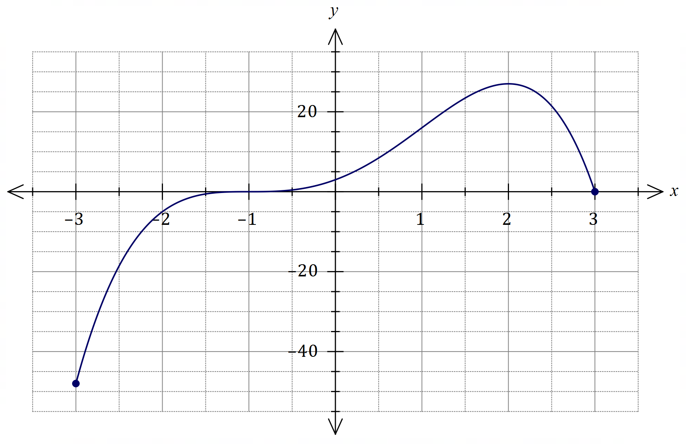

|  |
| --- |
| Solution |
| See graph |
| Specific behaviours |
| ✓ locates domain endpoints  ü axes intercepts  ü behaviour at stationary points  ü smooth curve throughout |

Question 12 (8 marks)

Data from repairs to $495$ smartphones showed that $340$ were Android and the remainder iOS. The type of repair was classified as screen or other, and of the $346$ smartphones that required screen repairs, $265$ were Android.

(a) Determine, to $3$ decimal places, the probability that a randomly selected smartphone from those repaired

(i) was an iOS smartphone. (2 marks)

|  |
| --- |
| Solution |
| $$495-340=155 \\ P(I)=\frac{155}{495}≈0.313$$ |
| Specific behaviours |
| ✓ calculates numerator  ü correct probability |

(ii) required a screen repair or was an Android smartphone. (2 marks)

|  |
| --- |
| Solution |
| $$346+340-265=421 \\ P(S∪A)=\frac{421}{495}≈0.851$$ |
| Specific behaviours |
| ✓ calculates numerator  ü correct probability |

(iii) was an iOS smartphone given that it required a screen repair. (2 marks)

|  |
| --- |
| Solution |
|  |
| Specific behaviours |
| ✓ indicates use of conditional probability  ü calculates probability |

(b) Use two of the above probabilities to explain whether the repair data indicates possible independence of type of smartphone and type of repair. (2 marks)

|  |
| --- |
| Solution |
| Independence appears unlikely since $P\left(I\right)=0.313$ is not close to . |
| Specific behaviours |
| ✓ states independence unlikely  ü justifies by comparing relevant probabilities |

Question 13 (7 marks)

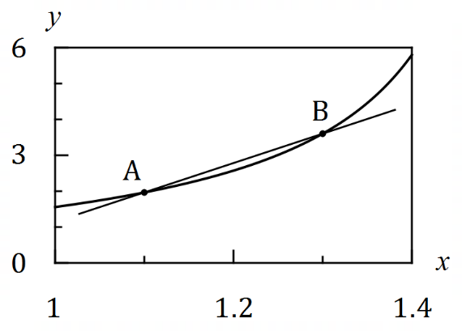Let $f\left(x\right)=\tan{x}$, where $x$ is measured  
in radians.

The graph of $y=f(x)$ is shown.

Two points, $A$ and $B$, lie on the curve with $x$ 
-coordinates $1.1$ and $1.1+h$ respectively,  
where $h>0$.

The secant through $AB$ is also shown.

(a) Use the difference quotient $\begin{matrix}δy \\ \overline{δx}\end{matrix}=\begin{matrix}f\left(x+h\right)-f(x) \\ \overline{ h }\end{matrix}$ to calculate, to $3$ decimal places, the slope of secant $AB$ when

|  |
| --- |
| Solution |
| $$\frac{δy}{δx}=\frac{\tan\left(1.3\right)-tan⁡(1.1)}{0.2}≈8.187$$ |
| Specific behaviours |
| ✓ uses correct values in quotient  ✓ correct value |

(i) $h=0.2$. (2 marks)

|  |
| --- |
| Solution |
| $$\frac{δy}{δx}=\frac{\tan\left(1.15\right)-tan⁡(1.1)}{0.05}≈5.395$$ |
| Specific behaviours |
| ✓ correct value |

(ii) $h=0.05$. (1 mark)

(b) Continue to show the use of the difference quotient to determine an estimate, correct to $3$ decimal places, for the slope of secant $AB$ as the value of $h$ tends to $0$. (3 marks)

|  |
| --- |
| Solution |
| $$h=0.01⇒\frac{δy}{δx}≈4.958$$ $$0<h≤0.000 02⇒\frac{δy}{δx}≈4.860$$ To $3$ dp, best estimate for gradient as $h→0$ is $4.860$. |
| Specific behaviours |
| ✓ calculates quotient with  ✓ calculates another quotient with smaller $h$ ü correct estimate, to $3$ dp |

(c) Briefly explain how your answer to part (b) relates to a feature of the graph of $y=f(x)$ at the point $A$. (1 mark)

|  |
| --- |
| Solution |
| It is the slope of the graph at the point $A$. |
| Specific behaviours |
| ✓ states slope at point |

Question 14 (8 marks)

Two events $A$ and $B$ are such that $P\left(A\right)=0.35$ and $P\left(B\right)=0.48$.

Determine the following probabilities.

(a) $P(\overline{A∪B})$ when $A$ and $B$ are mutually exclusive. (2 marks)

|  |
| --- |
| Solution |
| $$P\left(A∪B\right)=0.35+0.48=0.83$$ $$P\left(\overline{A∪B}\right)=1-0.83=0.17$$ |
| Specific behaviours |
| ✓ indicates $P(A∪B)$ ü correct probability |

(b) $P(A∪B)$ when $P\left(\overline{A}∩B\right)=0.25$. (2 marks)

|  |
| --- |
| Solution |
| $$P\left(A∪B\right)=P\left(A\right)+P(\overline{A}∩B) \\ =0.35+0.25=0.6$$ |
| Specific behaviours |
| ✓ indicates suitable method  ü correct probability |

(c) $P(A∩\overline{B})$ when $A$ and $B$ are independent. (2 marks)

|  |
| --- |
| Solution |
| $P\left(A∩B\right)=0.35×0.48=0.168$ OR $P\left(A∩\overline{B}\right)= P\left(A\right) P\left(\overline{B}\right)$ $P\left(A∩\overline{B}\right)=0.35-0.168=0.182$ $P\left(A∩\overline{B}\right)=0.35×0.52=0.182$ |
| Specific behaviours |
| ✓ indicates $P(A∩B)$ or $P\left(A∩\overline{B}\right)$ ü correct probability |

(d) $P(A|B)$ when $P\left(B | A\right)=0.2$. (2 marks)

|  |
| --- |
| Solution |
|  |
| Specific behaviours |
| ✓ indicates $P(A∩B)$ ü correct probability |

Question 15 (7 marks)

An aeroplane takes off from an airport situated at an altitude of $75$ metres above sea level and climbs $555$ metres during the first minute of flight. In each subsequent minute, its rate of climb reduces by $6\%$.

(a) Determine the **increase in altitude** of the aeroplane during the fifth minute. (2 marks)

|  |
| --- |
| Solution |
| |  |  |  |  |  |  | | --- | --- | --- | --- | --- | --- | | n (mins) | 1 | 2 | 3 | 4 | 5 | | Increase in A (m) | 555 | 555 x 0.94 | 555 x 0.942 | 555 x 0.943 | 555 x 0.944 | |
| Specific behaviours |
| ✓ indicates use of appropriate method  ü correct increase |

(b) Deduce a rule in simplified form for the **altitude $A_{n}$** of the aeroplane above sea level at the end of the $n^{\text{th}}$ minute. (3 marks)

|  |
| --- |
| Solution |
| $A_{n}$ will be sum of terms plus initial altitude: $$A_{n}=\frac{555\left(1-{0.94}^{n}\right)}{1-0.94}+75 \\ =9250\left(1-{0.94}^{n}\right)+75 \\ or 9325-9250{\left(0.94\right)}^{n}$$ |
| Specific behaviours |
| ✓ correct use of sum formula  ü includes initial altitude  ü simplifies (to last or second last line) |

(c) Determine the altitude of the aeroplane after $18$ minutes. (1 mark)

|  |
| --- |
| Solution |
| $$A_{18}=6213+75=6288 \text{m}$$ |
| Specific behaviours |
| ✓ calculates correct term |

(d) Determine the maximum altitude the aeroplane will reach. (1 mark)

|  |
| --- |
| Solution |
| $$A_{∞}=\frac{555}{0.06} +75$$ $$=9325 \text{m}$$ |
| Specific behaviours |
| ü correct altitude |

Question 16 (6 marks)

The sum of the first $n$ terms of a sequence is given by $S_{n}=2n^{2}+5n$.

(a) Determine $S_{6}$. (1 mark)

|  |
| --- |
| Solution |
| $$S_{6}=2{\left(6\right)}^{2}+5\left(6\right) \\ =102$$ |
| Specific behaviours |
| ✓ correct value |

(b) Determine $T_{6}$, where $T_{n}$ is the $n^{\text{th}}$ term of the sequence. (2 marks)

|  |
| --- |
| Solution |
| $$S_{5}=2{\left(5\right)}^{2}+5\left(5\right)=75 \\ T_{6}=S_{6}-S_{5} \\ =102-75 \\ =27$$ |
| Specific behaviours |
| ✓ calculates $S_{5}$ ü calculates $T_{6}$ |

(c) Explain why the sequence must be arithmetic and hence deduce a rule for the $n^{\text{th}}$ term of the sequence. (3 marks)

|  |
| --- |
| Solution |
| The rule for $S_{n}$ is quadratic and so the second difference of the sums will be constant and equal to the common difference of the sequence. $$T_{1}=S_{1}=7 \\ T_{2}=S_{2}-T_{1}=18-7=11 \\ d=T_{2}-T_{1}=11-7=4$$ $$T_{n}=7+\left(n-1\right)\left(4\right)=4n+3$$ |
| Specific behaviours |
| ✓ any reasonable explanation  ü calculates common difference  ü correct rule |

Question 17 (10 marks)

Particle P is moving along the $x$-axis so that its displacement, in cm, at time $t$ seconds, $t≥0$, is given by $x=2.7+0.6t-0.1t^{2}$.

(a) Sketch the displacement-time graph of particle P on the axes below. (3 marks)

|  |
| --- |
| Solution |
| See graph |
| Specific behaviours |
| ü turning point  ü both intercepts  ü parabolic shape |

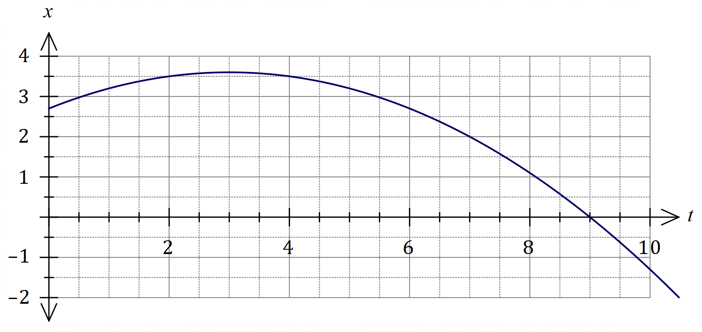

(b) Determine the velocity of particle P at the instant it reaches the origin. (3 marks)

|  |
| --- |
| Solution |
| Reaches origin when $x=0⇒t=9$. $$v=\frac{dx}{dt}=0.6-0.2t$$ $$v\left(9\right)=0.6-0.2\left(9\right)=-1.2 \text{cm/s}$$ |
| Specific behaviours |
| ✓ indicates correct time  ü obtains velocity function  ü correct velocity |

(c) Particle Q is also moving along the $x$-axis, but with a constant velocity. When $t=6$, it has the same displacement and velocity as particle P. Determine when particle Q reaches the origin. (4 marks)

|  |
| --- |
| Solution |
| $$x\left(6\right)=2.7, v\left(6\right)=-0.6$$ Displacement equation (tangent to curve at $t=6$): $$x-2.7=-0.6\left(t-6\right) \\ x=6.3-0.6t$$ Reaches origin: $$6.3-0.6t=0⇒t=10.5$$ Hence Q reaches origin when $t=10.5$ seconds. |
| Specific behaviours |
| ✓ initial displacement and velocity  ü displacement equation for Q  ü equates displacement to $0$ ü solves for correct time |

Question 18 (7 marks)

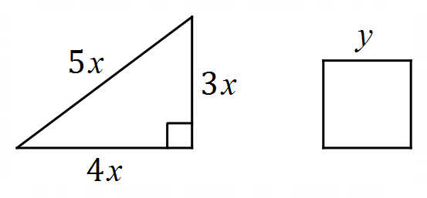A length of wire $72$ cm long is cut into two pieces.  
One piece is bent into a right triangle with sides  
of length $3x, 4x$ and $5x$ cm and the other piece  
is bent into a square of side $y$ cm.

Formulate an expression for the combined area of the triangle and square in terms of $x$ and hence use calculus to determine the minimum value of this total area.

|  |
| --- |
| Solution |
| $$12x+4y=72⇒y=18-3x$$ $$A=\frac{1}{2}\left(4x\right)\left(3x\right)+y^{2} \\ =6x^{2}+{\left(18-3x\right)}^{2} \\ =15x^{2}-108x+324$$ $$\frac{dA}{dx}=30x-108 \\ 30x-108=0 \\ x=\frac{18}{5}=3.6$$ $$A(3.6)=15{\left(3.6\right)}^{2}-108\left(3.6\right)+324 \\ =\frac{648}{5}=129.6$$ The minimum total area is $129.6 {\text{cm}}^{2}$. |
| Specific behaviours |
| ✓ equation relating $x$ and $y$ ü total area in terms of $x$ and $y$ ü total area in terms of $x$ ü derivative  ü equates derivative to $0$ ü optimum value of $x$ ü calculates and states minimum area |

Question 19 (8 marks)

A random selection of $4$ paint brushes is made from a collection of $16$ different brushes, $9$ of which are flat and the remainder round.

(a) Show that the probability the selection contains all round brushes is $\begin{matrix}1 \\ \overline{52}\end{matrix}$. (3 marks)

|  |
| --- |
| Solution |
| Total possible selections is $\left(\begin{matrix}16 \\ 4\end{matrix}\right)=1820$.  Ways to select all round is $\left(\begin{matrix}7 \\ 4\end{matrix}\right)=35$. $$P\left(\text{All Round}\right)=\frac{ \left(\begin{matrix}9 \\ 0\end{matrix}\right) \left(\begin{matrix}7 \\ 4\end{matrix}\right)}{ \left(\begin{matrix}16 \\ 4\end{matrix}\right)}= \frac{35}{1820}=\frac{1}{52}$$ |
| Specific behaviours |
| ✓ calculates number of all possible selections  ü calculates number of ways to select all round  ü uses counts to form probability |

(b) Determine the probability that the selection contains

(i) all flat brushes. (2 marks)

|  |
| --- |
| Solution |
| Ways to select all flat is $\left(\begin{matrix}9 \\ 4\end{matrix}\right)=126$. $$P\left(\text{All Flat}\right)=\frac{ \left(\begin{matrix}9 \\ 4\end{matrix}\right) \left(\begin{matrix}7 \\ 0\end{matrix}\right)}{ \left(\begin{matrix}16 \\ 4\end{matrix}\right)}= \frac{126}{1820}=\frac{9}{130} (≈0.06923)$$ |
| Specific behaviours |
| ✓ calculates number of ways to select all flat  ✓ correct probability |

(ii) at least one round brush. (1 mark)

|  |
| --- |
| Solution |
| $$P=1-\frac{9}{130} =\frac{121}{130} (≈0.93077)$$ |
| Specific behaviours |
| ✓ correct probability |

(iii) at least one round brush and at least one flat brush. (2 marks)

|  |
| --- |
| Solution |
| $$P\left(\text{All of same type}\right)=\frac{1}{52}+\frac{9}{130}=\frac{23}{260}$$ $$P=1-\frac{23}{260}=\frac{237}{260} (≈0.9115)$$ |
| Specific behaviours |
| ✓ probability of all of same type  ü correct probability |

Question 20 (9 marks)

The graph of the hyperbola $y=\begin{matrix}a \\ \overline{x+b}\end{matrix}$ is shown below, where $a$ and $b$ are constants.

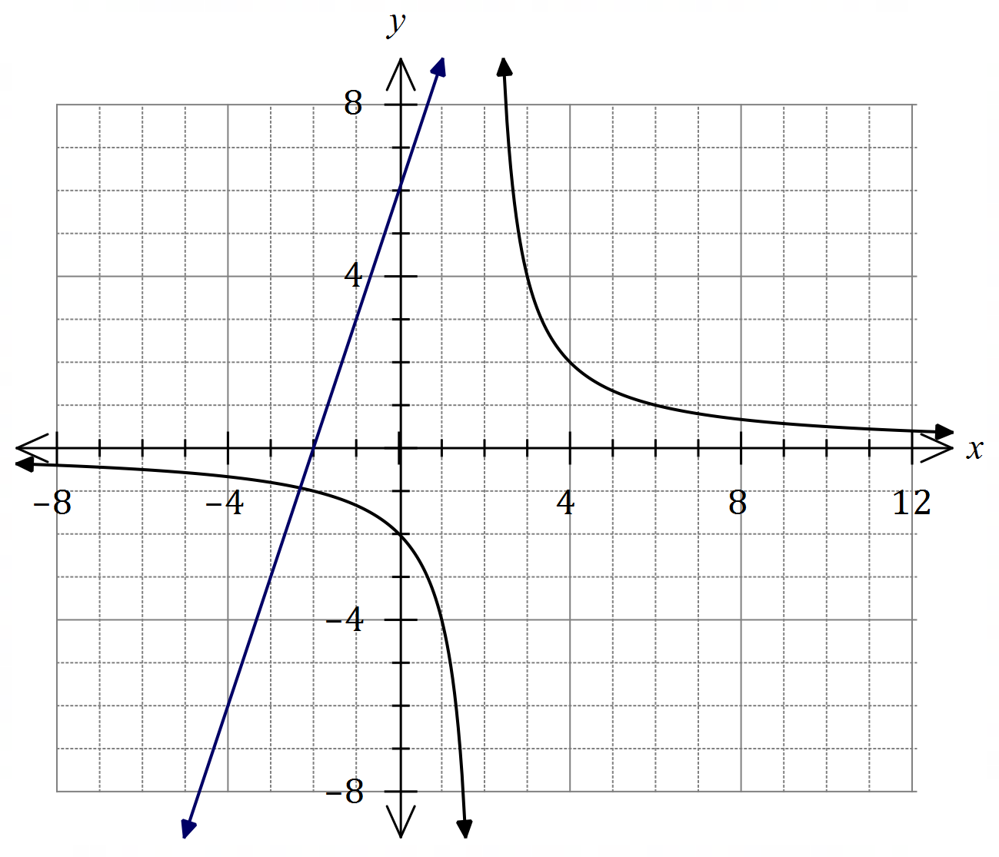

(a) State the equations of all asymptotes of the hyperbola. (2 marks)

|  |
| --- |
| Solution |
| Horizontal: $y=0$ Vertical: $x=2$. |
| Specific behaviours |
| ✓ equation for horizontal asymptote  ✓ equation for vertical asymptote |

(b) Determine the value of $a$ and the value of $b$. (2 marks)

|  |
| --- |
| Solution |
| From asymptote, $b=-2$.  Using $(0, -2)$: $$-2=\frac{a}{0-2}⇒a=4$$ |
| Specific behaviours |
| ✓ value of $a$ ü value of $b$ |

(c) Add the line $y=3x+6$ to the graph of the hyperbola and state the number of points of intersection it will have with the hyperbola. (2 marks)

|  |
| --- |
| Solution |
| See graph for line. It will have $2$ points of intersection with the hyperbola. |
| Specific behaviours |
| ✓ correct line  ü correct number of intersections |

(d) The line $y=mx+6$ is tangential to the hyperbola, where $m$ is a constant. Use an algebraic method to determine all possible values of $m$. (3 marks)

|  |
| --- |
| Solution |
| Require one solution to intersection of lines: $$\frac{4}{x-2}=mx+6 \\ 4=\left(x-2\right)\left(mx+6\right) \\ mx^{2}+\left(6-2m\right)x-16=0$$ For one solution, quadratic discriminant $Δ=b^{2}-4ac=0$: $$Δ={\left(6-2m\right)}^{2}-4\left(m\right)\left(-16\right)=0$$ Using CAS: $m=-1, m=-9$. |
| Specific behaviours |
| ✓ obtains quadratic from equating both functions  ü uses discriminant to form equation in $m$ ü both correct values |

Question 21 (10 marks)

Three small weights $A, B$ and $C$, each attached to a spring, are oscillating vertically above level ground. The height, $h$ cm, above the ground of each weight at time $t$ seconds, $t≥0,$ is given by

$$h_{A}=16\cos\left(\begin{matrix}3πt \\ \overline{ 4 }\end{matrix}\right)+20, h_{B}=12\sin\left(\begin{matrix}3πt \\ \overline{ 4 }\end{matrix}\right)+25, h_{C}=12\cos\left(\begin{matrix}5πt \\ \overline{ 4 }\end{matrix}\right)+20.$$

(a) State which two weights are oscillating with the same amplitude, and state what this common amplitude is. (2 marks)

|  |
| --- |
| Solution |
| Weights $B$ and $C$- their amplitude is $12$ cm. |
| Specific behaviours |
| ✓ correct weights  ü correct amplitude |

(b) State which two weights are oscillating with the same period, and state what this common period is. (2 marks)

|  |
| --- |
| Solution |
| Weights $A$ and $B$- their period is $2π÷\frac{3π}{4}=\frac{8}{3}$ s. |
| Specific behaviours |
| ✓ correct weights  ü correct period |

(c) State which of the weights reaches furthest above the ground and state the time at which it first reaches this position. (3 marks)

|  |
| --- |
| Solution |
| $$h_{A}=20+16=36, h_{B}=25+12=37, h_{C}=20+12=32$$ Hence weight $B$ reach*es* furthest above the ground.  When: $12\sin\left(\begin{matrix}3πt \\ \overline{ 4 }\end{matrix}\right)+25 = 37$ $$\sin\left(\frac{3πt}{4}\right) =1 ⇒ \frac{3πt}{4}=\frac{π}{2} ⇒ t=\frac{2}{3}$$ This first occurs when $t=\frac{2}{3}$ sec or 0. $\overline{6}$ sec |
| Specific behaviours |
| ✓ states correct weight  ü equates $h_{B}$ to 37  ü states correct time |

(d) Determine the length of time during the first $3$ seconds for which $h_{C}>h_{A}>h_{B}$. (3 marks)

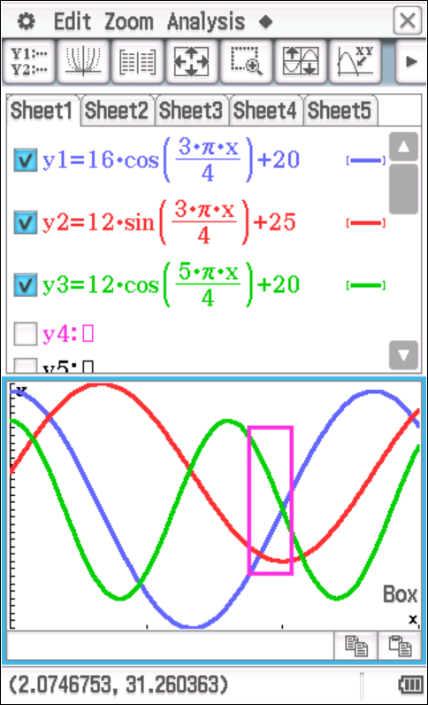

|  |
| --- |
| Solution |
| Use CAS to graph heights and identify required interval. $$h_{A}=h_{B}→t=1.8341 \\ h_{A}=h_{C}→t=2$$ Length of time: $Δt=$ 2 – 1.8341 $$=0.1659 \\ ≈0.166 \text{s}$$ |
| Specific behaviours |
| ✓ indicates one endpoint  ü indicates second endpoint  ü calculates difference |

Supplementary page

Question number: _________

Supplementary page

Question number: _________

© 2021 WA Exam Papers. Willetton Senior High School has a non-exclusive licence to copy and communicate this document for non-commercial, educational use within the school. No other copying, communication or use is permitted without the express written permission of WA Exam Papers. SN115-182-4.